**LAB SESSION 9**

**InkWell Widget & ScrollView**

**Objective:**

To understand the usage of the InkWell widget for handling tap gestures and ScrollView for scrolling content in a Flutter app.

**Introduction:**

**1. InkWell Widget:** The InkWell widget is a Material Design widget in Flutter that responds to touch events, such as taps, clicks, and long presses. It provides visual feedback to users by displaying a ripple effect when tapped, giving the impression of interaction. InkWell is commonly used to make various UI elements, such as buttons, icons, or entire widgets, interactive.

**Key Features of InkWell:**

**Tappable Area:** InkWell expands its tappable area to match the size of its child widget by default. However, developers can customize the size using the customBorder property.

**Visual Feedback:** When tapped, InkWell displays a visual ripple effect that spreads outward from the point of touch, indicating the user's interaction with the widget**.**

**Gesture Detection**: InkWell supports various touch gestures, including onTap, onDoubleTap, onLongPress, and onTapCancel, allowing developers to trigger different actions based on user input.

**Accessibility**: InkWell ensures accessibility by providing support for both touch and keyboard interactions. It also supports tooltips to provide additional context to users.

**Material Design Integration:** InkWell is part of the Material Design system and seamlessly integrates with other Material widgets and components.

import 'package:flutter/material.dart';

void main() {

runApp(const MyApp());

}

class MyApp extends StatelessWidget {

const MyApp({super.key});

@override

Widget build(BuildContext context) {

return MaterialApp(

DEPARTMENT OF SOFTWARE ENGINEERING MOBILE APPLICATION DEVELOPMENT (SE-487)

title:'flutter demo',

debugShowCheckedModeBanner: false,

theme:ThemeData(

primarySwatch:Colors.*lightBlue*,

),

home:const MyHomePage(),

);

}

}

class MyHomePage extends StatefulWidget {

const MyHomePage({Key?key}):super(key:key);

@override

State<MyHomePage> createState() => _MyHomePageState(); }

class _MyHomePageState extends State<MyHomePage>

{

@override

Widget build(BuildContext context) {

return Scaffold(

appBar: AppBar(

backgroundColor: Colors.*teal*,

title: Text('ink well widget',style: TextStyle(fontSize: 26,color:Colors.*white*),), 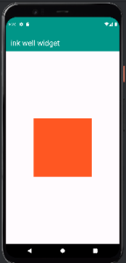

),

body:

Center(

child: InkWell(

onLongPress:()

{

print('long pressed');

},

onDoubleTap: ()

{

print('double tapped');

},

onTap: ()

{

print('tapped');

},

child: Container(

height: 200,

width: 200,

color: Colors.*deepOrange*,

DEPARTMENT OF SOFTWARE ENGINEERING MOBILE APPLICATION DEVELOPMENT (SE-487)

),

),

)

);

}

}

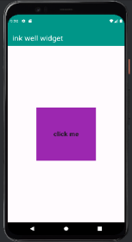

import 'package:flutter/material.dart';

void main() {

runApp(const MyApp());

}

class MyApp extends StatelessWidget {

const MyApp({super.key});

@override

Widget build(BuildContext context) {

return MaterialApp(

title:'flutter demo',

debugShowCheckedModeBanner: false,

theme:ThemeData(

primarySwatch:Colors.*lightBlue*,

),

home:const MyHomePage(),

);

}

}

class MyHomePage extends StatefulWidget {

const MyHomePage({Key?key}):super(key:key);

@override

State<MyHomePage> createState() => _MyHomePageState(); }

class _MyHomePageState extends State<MyHomePage>

{

@override

Widget build(BuildContext context) {

DEPARTMENT OF SOFTWARE ENGINEERING MOBILE APPLICATION DEVELOPMENT (SE-487)

return Scaffold(

appBar: AppBar(

backgroundColor: Colors.*teal*,

title: Text('ink well widget',style: TextStyle(fontSize: 26,color:Colors.*white*),),

),

body:

Center(

child: Container(

height: 200,

width: 200,

color: Colors.*purple*,

child: Center(

child: InkWell(

onLongPress: (){

print('long pressed');

},

onDoubleTap: ()

{

print('text is double tapped'); },

child: Text("click me",

style: TextStyle(fontSize: 22, fontWeight: FontWeight.*bold*),

)

)

),

),

),

);

}

}

DEPARTMENT OF SOFTWARE ENGINEERING MOBILE APPLICATION DEVELOPMENT (SE-487) 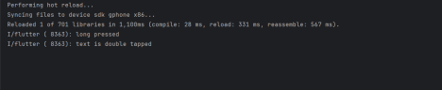

**2. ScrollView**

ScrollView is a widget in Flutter that provides scrolling functionality to its child widgets when the content exceeds the available space. It allows users to scroll vertically, horizontally, or both directions to view content that does not fit within the screen dimensions. ScrollView is commonly used to create scrollable lists, grids, and custom layouts.

**Key Features of ScrollView:**

**Scroll Direction:** ScrollView supports both vertical and horizontal scrolling, depending on the scroll direction specified using the scrollDirection property.

**Scroll Physics:** Developers can customize the scroll behavior by providing different scroll physics, such as ClampingScrollPhysics, BouncingScrollPhysics, or AlwaysScrollableScrollPhysics.

**Scroll Controllers**: ScrollView can be controlled using ScrollController to programmatically scroll to specific positions or animate scrolling effects.

**Performance Optimization:** ScrollView efficiently handles large amounts of content by lazily loading and unloading child widgets as they become visible or invisible within the viewport, thereby optimizing performance.

**Nested Scrolling:** ScrollView supports nested scrolling, allowing multiple scrollable widgets to be nested within each other to create complex layouts

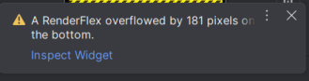

DEPARTMENT OF SOFTWARE ENGINEERING MOBILE APPLICATION DEVELOPMENT (SE-487)

import 'package:flutter/material.dart'; 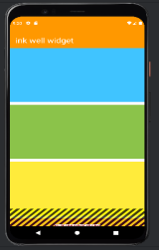

void main() {

runApp(const MyApp());

}

class MyApp extends StatelessWidget {

const MyApp({super.key});

@override

Widget build(BuildContext context) {

return MaterialApp(

title:'flutter demo',

debugShowCheckedModeBanner: false,

theme:ThemeData(

primarySwatch:Colors.*lightBlue*,

),

home:const MyHomePage(),

);

}

}

class MyHomePage extends StatefulWidget {

const MyHomePage({Key?key}):super(key:key);

@override

State<MyHomePage> createState() => _MyHomePageState(); }

class _MyHomePageState extends State<MyHomePage>

{

@override

Widget build(BuildContext context) {

return Scaffold(

appBar: AppBar(

backgroundColor: Colors.*orange*,

title: Text('ink well widget',style: TextStyle(fontSize: 26,color:Colors.*white*),),

),

body: Padding(

padding: const EdgeInsets.all(8.0),

child: SingleChildScrollView(

child: Column(

children: <Widget>[

Container(

height: 200,

width: 400,

color: Colors.*lightBlueAccent*,

margin: EdgeInsets.only(bottom: 11),

),

DEPARTMENT OF SOFTWARE ENGINEERING MOBILE APPLICATION DEVELOPMENT (SE-487)

Container(

height: 200,

width: 400,

color: Colors.*lightGreen*,

margin: EdgeInsets.only(bottom: 11),

),

Container(

height: 200,

width: 400,

color: Colors.*yellow*,

margin: EdgeInsets.only(bottom: 11),

),

Container(

height: 200,

width: 400,

color: Colors.*pink*,

margin: EdgeInsets.only(bottom: 11), ),

Container(

height: 200,

width: 400,

color: Colors.*lightBlueAccent*,

margin: EdgeInsets.only(bottom: 11),

),

Container(

height: 200,

width: 400,

color: Colors.*lightGreen*,

margin: EdgeInsets.only(bottom: 11),

),

Container(

height: 200,

width: 400,

color: Colors.*yellow*,

margin: EdgeInsets.only(bottom: 11),

),

Container(

height: 200,

width: 400,

color: Colors.*pink*,

margin: EdgeInsets.only(bottom: 11),

),

],

),

),

)

DEPARTMENT OF SOFTWARE ENGINEERING MOBILE APPLICATION DEVELOPMENT (SE-487)

);

}

}

import 'package:flutter/cupertino.dart'; 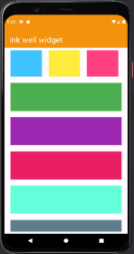

import 'package:flutter/material.dart';

void main() {

runApp(const MyApp());

}

class MyApp extends StatelessWidget {

const MyApp({super.key});

@override

Widget build(BuildContext context) {

return MaterialApp(

title:'flutter demo',

debugShowCheckedModeBanner: false,

theme:ThemeData(

primarySwatch:Colors.*lightBlue*,

),

home:const MyHomePage(),

);

}

}

class MyHomePage extends StatefulWidget {

const MyHomePage({Key?key}):super(key:key);

@override

State<MyHomePage> createState() => _MyHomePageState(); }

class _MyHomePageState extends State<MyHomePage>

{

@override

Widget build(BuildContext context) {

return Scaffold(

appBar: AppBar(

backgroundColor: Colors.*orange*,

title: Text('ink well widget',style: TextStyle(fontSize: 26,color:Colors.*white*),),

),

body: Padding(

padding: const EdgeInsets.all(8.0),

child: SingleChildScrollView(

DEPARTMENT OF SOFTWARE ENGINEERING MOBILE APPLICATION DEVELOPMENT (SE-487)

child: Column(

children: <Widget>[

SingleChildScrollView(

scrollDirection: Axis.horizontal, child: Row(

children: [

Container(

height: 100,

width:100,

color: Colors.*lightBlueAccent*,

margin: EdgeInsets.all(11),

),

Container(

height: 100,

width:100,

color: Colors.*yellow*,

margin: EdgeInsets.all(11),

),

Container(

height: 100,

width:100,

color: Colors.*pinkAccent*,

margin: EdgeInsets.all(11),

),

Container(

height: 100,

width:100,

color: Colors.*lightBlueAccent*, margin: EdgeInsets.all(11),

),

Container(

height: 100,

width:100,

color: Colors.*purpleAccent*, margin: EdgeInsets.all(11),

),

],

),

),

Container(

height: 100,

color: Colors.*green*,

margin: EdgeInsets.all(11),

),

DEPARTMENT OF SOFTWARE ENGINEERING MOBILE APPLICATION DEVELOPMENT (SE-487)

Container(

height: 100,

color: Colors.*purple*,

margin: EdgeInsets.all(11),

),

Container(

height: 100,

color: Colors.*pink*,

margin: EdgeInsets.all(11),

),

Container(

height: 100,

color: Colors.*tealAccent*,

margin: EdgeInsets.all(11),

),

Container(

height: 100,

color: Colors.*blueGrey*,

margin: EdgeInsets.all(11),

),

Container(

height: 100,

color: Colors.*orange*,

margin: EdgeInsets.all(11),

),

],

),

),

)

);

}

}

DEPARTMENT OF SOFTWARE ENGINEERING MOBILE APPLICATION DEVELOPMENT (SE-487)

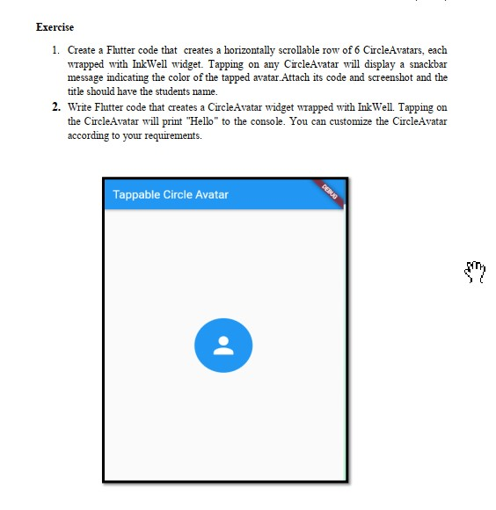

**TASK # 01:**

//Musadiuqe Hussain SE-21031

//Muhammad Asim SE-21045

import 'package:flutter/material.dart';

void main() {

  runApp(MyApp());

}

class MyApp extends StatelessWidget {

  @override

  Widget build(BuildContext context) {

    return MaterialApp(

      debugShowCheckedModeBanner:false,

      title: 'Musadique Hussain SE-21031',

      theme: ThemeData(

        primarySwatch: Colors.blue,

      ),

      home: AvatarScrollScreen(),

    );

  }

}

class AvatarScrollScreen extends StatelessWidget {

  final List<Color> avatarColors = [

    Colors.teal,

    Colors.indigo,

    Colors.pink,

    Colors.cyan,

    Colors.lime,

    Colors.amber,

  ];

  void _showSnackBar(BuildContext context, Color color) {

    final snackBar = SnackBar(

      content: Text('Tapped on color: ${color.toString()}'),

    );

    ScaffoldMessenger.of(context).showSnackBar(snackBar);

  }

  @override

  Widget build(BuildContext context) {

    return Scaffold(

      appBar: AppBar(

        title: Text('Musadique SE-21031'),

        backgroundColor: Colors.blue,

        foregroundColor: Colors.white,

      ),

      body: Center(

        child: SingleChildScrollView(

          scrollDirection: Axis.horizontal,

          child: Row(

            mainAxisAlignment: MainAxisAlignment.center,

            children: avatarColors.map((color) {

              return Padding(

                padding: const EdgeInsets.all(8.0),

                child: GestureDetector(

                  onTap: () => _showSnackBar(context, color),

                  child: CircleAvatar(

                    backgroundColor: color,

                    radius: 30,

                    child: Icon(Icons.person, color: Colors.white),

                  ),

                ),

              );

            }).toList(),

          ),

        ),

      ),

    );

  }

}

OUTPUT:

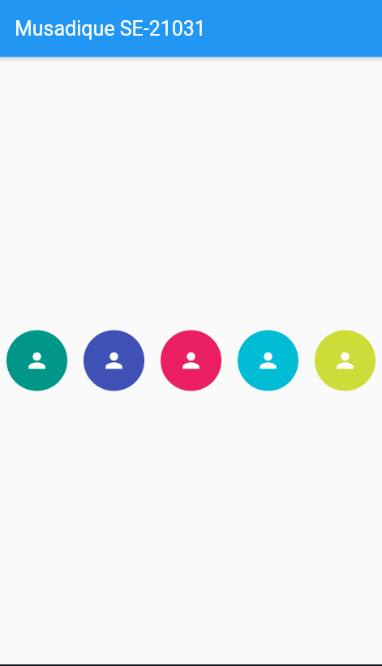

**TASK # 02:**

//Musadique Hussain SE-21031

//Muhammad Asim SE-21045

import 'package:flutter/material.dart';

void main() {

  runApp(MyApp());

}

class MyApp extends StatelessWidget {

  @override

  Widget build(BuildContext context) {

    return MaterialApp(

      debugShowCheckedModeBanner: false,

      title: 'Tappable Circle Avatar',

      theme: ThemeData(

        primarySwatch: Colors.blue,

      ),

      home: CircleAvatarScreen(),

    );

  }

}

class CircleAvatarScreen extends StatelessWidget {

  void _printMessage() {

    print('Hello');

  }

  @override

  Widget build(BuildContext context) {

    return Scaffold(

      appBar: AppBar(

        title: Text('Tappable Circle Avatar Musadique SE-21031'),

      ),

      body: Center(

        child: InkWell(

          onTap: _printMessage,

          child: CircleAvatar(

            backgroundColor: Colors.blue,

            radius: 50,

            child: Icon(

              Icons.person,

              color: Colors.white,

              size: 50,

            ),

          ),

        ),

      ),

    );

  }

}

OUTPUT:

